Name Date Period

Worksheet: Punnett Square Review

- In pea plants, tall (T) plants are dominant over short (t) plants. Complete the following crosses and give the genotypic and phenotypic ratios of offspring.

  - TT x tt

  - Tt x tt

  - Tt x Tt

- In pea plants, purple flowers (P) are dominant over white (p) flowers. Complete the following crosses and give the genotypic and phenotypic ratios of offspring.

  - A heterozygous purple plant is crossed with a homozygous purple plant.

  - A cross between two pea plants produces offspring in which approximately 50% of the flowers are white and 50% are purple. What are the genotypes of the parents? Show punnett square to support your answer.

  - A cross between two purple pea plants yields approximately 25% of the offspring exhibiting white flowers. What are the genotypes of the parents? Show punnett square to support your answer.

- A widow’s peak in humans is determined by a dominant/recessive inheritance. A person who is purebred for widow’s peak is crossed with a person who is purebred for no widow’s peak. All of the offspring have a widow’s peak. Which trait is dominant and which is recessive? Show punnett square to support your answer.

- In guinea pigs, black fur is dominant. If a black guinea pig is crossed with a white guinea pig and the litter contains a white offspring, the genotype of the black-haired parent is probably? Show punnett square to support your answer.

- In minks, brown is dominant over silver-blue color.

  - What offspring would you predict if you crossed a homozygous brown mink with a silver-blue mink? Show punnett square to support your answer.

  - What would the genotypic and phenotypic ratios of two F2 generation mink from the above problem be if they were crossed? Show punnett square to support your answer.

- In snapdragons, red is not completely dominant over white flowers.

  - What color flowers would you expect when you cross a red flower with a white flower? What would be the genotypic and phenotypic ratios of the offspring be?

  - Cross two of the F1 generation from above. What would be the genotypic and phenotypic ratios of the offspring be?

- In dragons, the ability to breath fire is a recessive trait. Homozygous dominant dragons cannot produce fire or smoke at all. Heterozygous dragons can produce smoke, but no fire.

  - Cross a fire breathing dragon with a homozygous dominant dragon. What would be the genotypic and phenotypic ratios of the offspring be?

  - Cross two smoke-producing only dragons. Are any of the offspring able to produce fire? Show punnett square to support your answer.

- In cattle, red and white hair are codominant. The heterozygous condition is roan colored (contains both red hair and white hair)

  - Cross a red cow and a white cow. What would be the genotypic and phenotypic ratios of the offspring be?

  - Would it be possible to have any red cattle when two roan cattle are crossed? Show punnett square to support your answer.

- In Guinea pigs, the genotype (BB) is black, and the genotype (bb) is white color, and (Bb) is grey color, The gene (B) and (b) are sex-linked.

  - What type of offspring are to be expected in a cross between a black female and a white male?

  - A heterozygous female is crossed with a white male. What are the expected genotypic and phenotypic ratios of the offspring?

  - Would it ever be possible to produce a male with grey hair? Explain

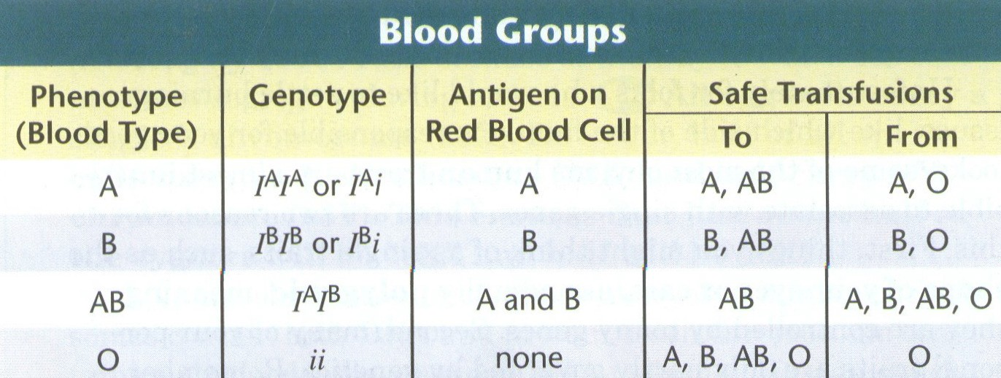
- The chart below shows the inheritance of human blood types. There are four different phenotypes possible: A, B, AB, and O. The alleles A and B are codominant, and the O allele is recessive to both A and B.

  - A person with IAIB is crossed with a person who is IAIA. What are the genotypic and phenotypic ratios of the offspring?

  - A person with type AB blood is crossed with a person with type O blood. What are the genotypic and phenotypic ratios of the offspring?

DIHYBRID PUNNETT SQUARE PRACTICE PROBLEMS

Problem A: Suppose that black hair (B) is dominant over blonde hair (b) and brown eyes (E) are dominant over blue eyes (e).
The father has black hair (heterozygous) and brown eyes (heterozygous) and the mother has blonde hair and blue eyes.
Genotype of father – BbEe Genotype of mother - bbee

- What percent of the offspring will be totally heterozygous?

- What is the phenotype ratio?

- What percent of the offspring will have blonde hair and blue eyes?

Problem B: Using the same traits as above, cross a completely recessive person with a blonde hair and homozygous brown eyed person.

- What percent of the offspring will be totally heterozygous?

- What is the phenotype ratio?

- What percent of the offspring will have blonde hair and blue eyes?

